Assignment 2

Network Scanning & Threat Analysis
Name : Kallem Architha
Email : archithareddykallem@gmail.com
Batch : z-12-13
Part A: Nmap Scanning
1.Basic Nmap scans:
nmap target {target ipaddress} : nmap 172.20.10.2
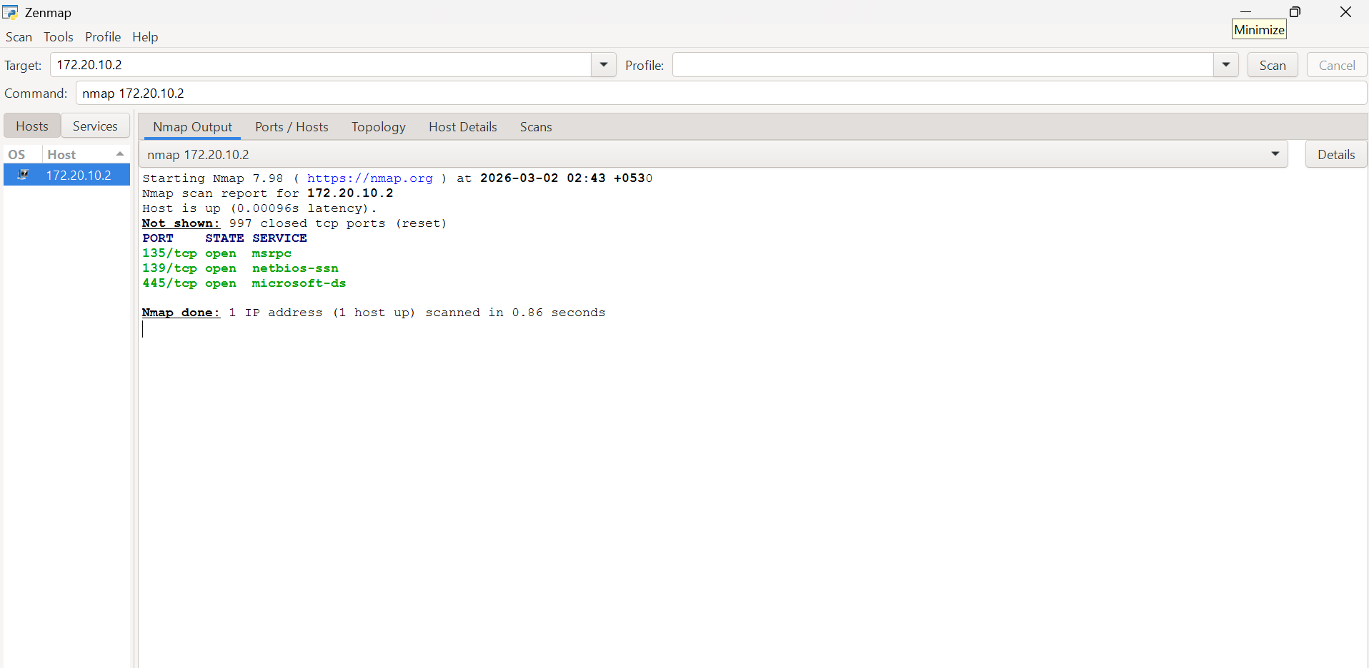
Its usage : It is the basic command of nmap where it scans the target ip address for top most open ports, when specify how many ports to check it checks top 1000 ports as we didn’t specified here it is checking for top 1000 open ports and gives info for open ports such as port number, state, service running on that port

2.Scanning Nmap Ip ranges:
nmap ipaddress{from} - ipaddress{to} : nmap 172.20.10.2 - 172.20.10.100
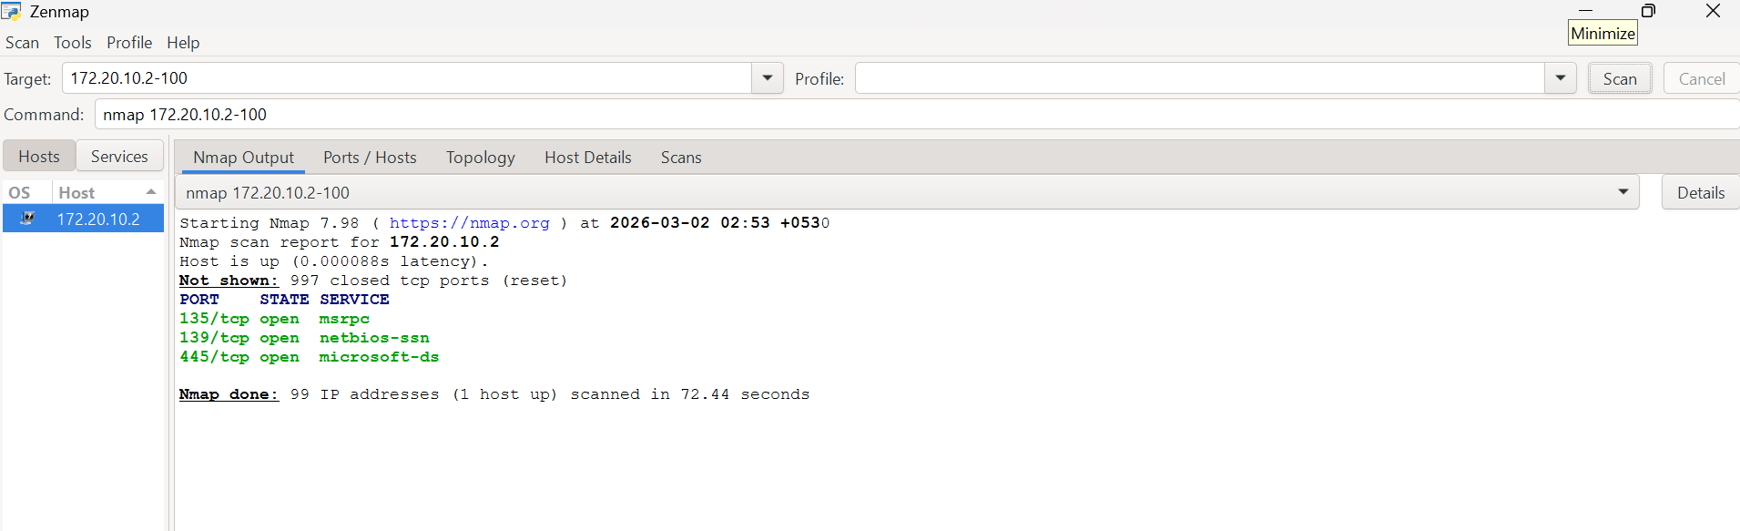
Its usage : It scans all the ip address that are in range ‘from’ to ‘to’ and for top most open ports and gives info for open ports in the particular ip address range such as port number, state, service running on that port

3.Scanning multiple ip address using single Nmap command:
nmap ipaddress_1 ipaddress_2 ipaddress_3 : nmap 172.20.10.2 172.20.10.3 172.20.10.4
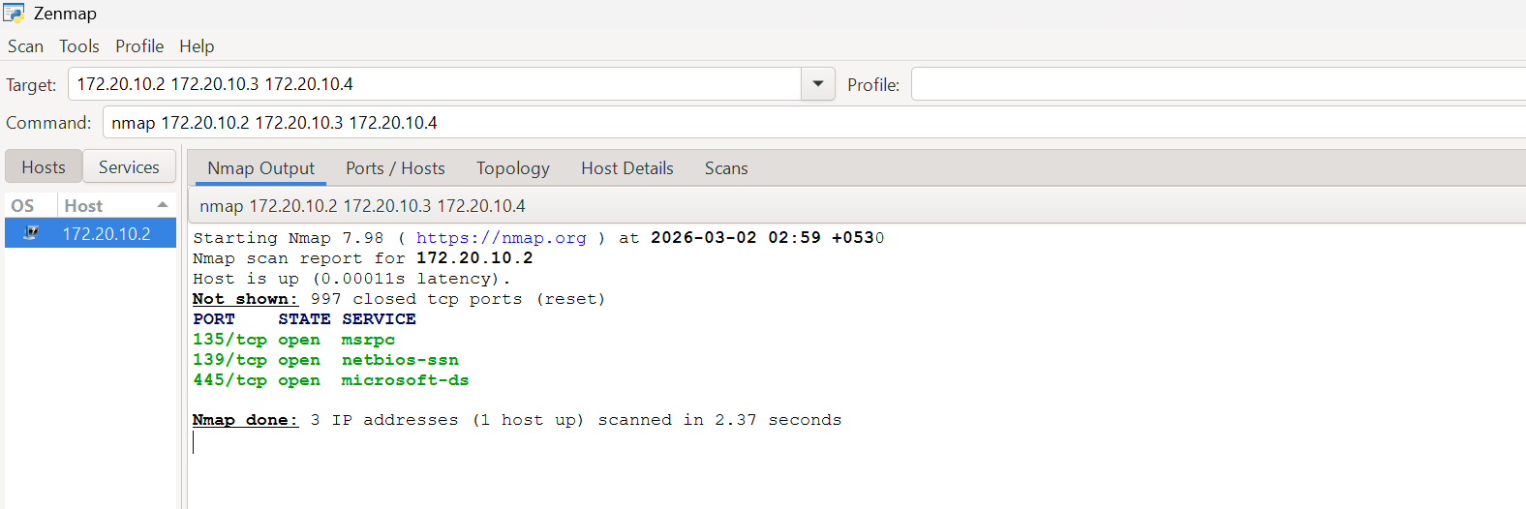
Its usage : We use this command when we want to scan multiple ip address in one single command It scans all the ip address that are listed and for top most open ports and gives info for open ports in the particular ip address range such as port number, state, service running on that port

4.Scanning a particular port on a target ip:
nmap -p {port number} target_ip : nmap -p 80 172.20.10.2
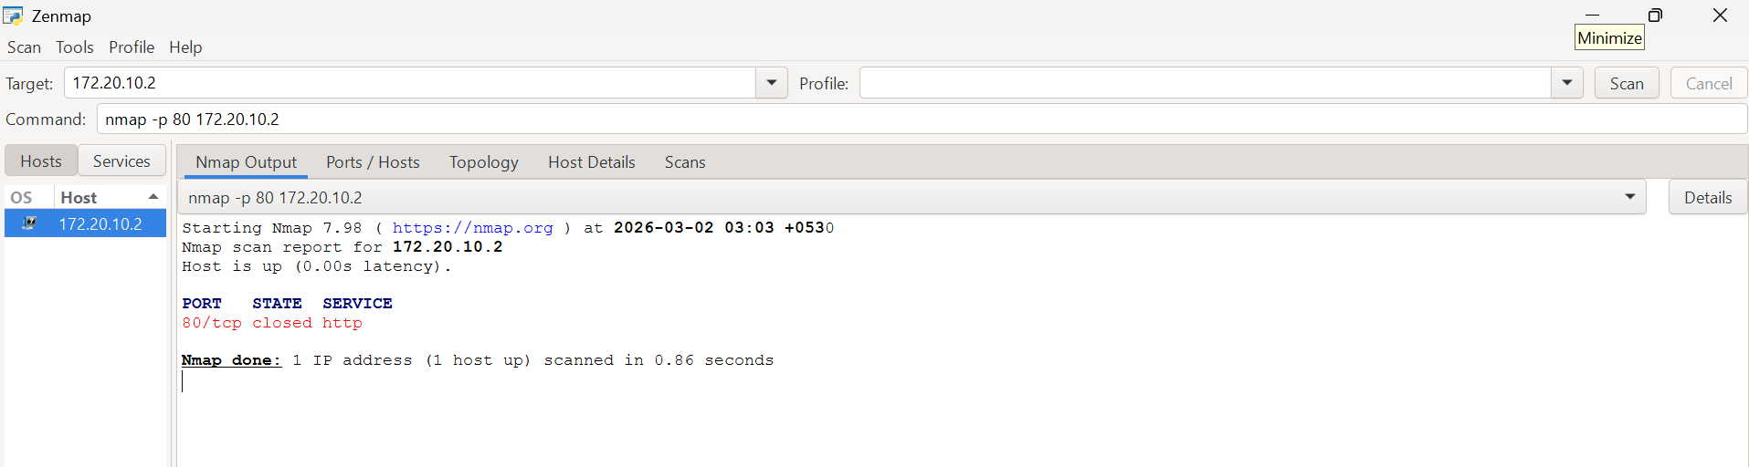
Its usage : This command gives info about particular port on target ip address. It specifies portnumber,state,service that can be run on that port number

5.Scanning Multiple particular ports on a target ip:
nmap -p {portnumber_1, port_number_2, portnumber_3} target_ip : nmap -p 22,21,80,443,25 172.20.10.2
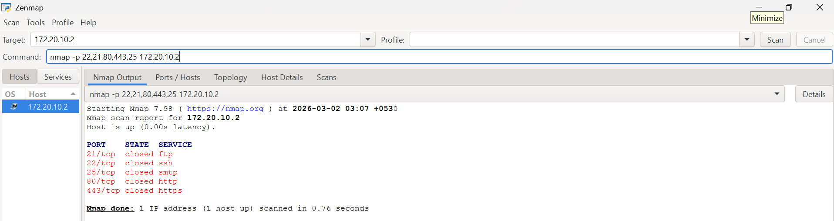
Its usage : This command gives info about particular ports on target ip address. It specifies portnumber,state,service that can be run on that port number

6.Scanning ports in a range on target ip:
nmap -p portnumber{from} - portnumber {to} target_ip : nmap -p 1-200 172.20.10.2
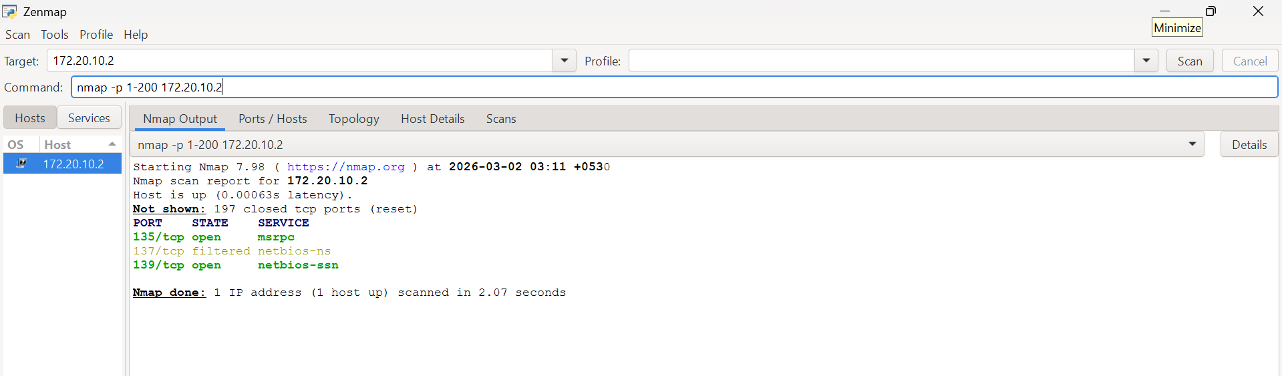
Its usage : This command gives info about particular range of open ports on target ip address. It specifies portnumber,state,service that can be run on that port number

7.Scanning top 100 ports on target ip:
nmap -F target_ip : nmap -F 172.20.10.2
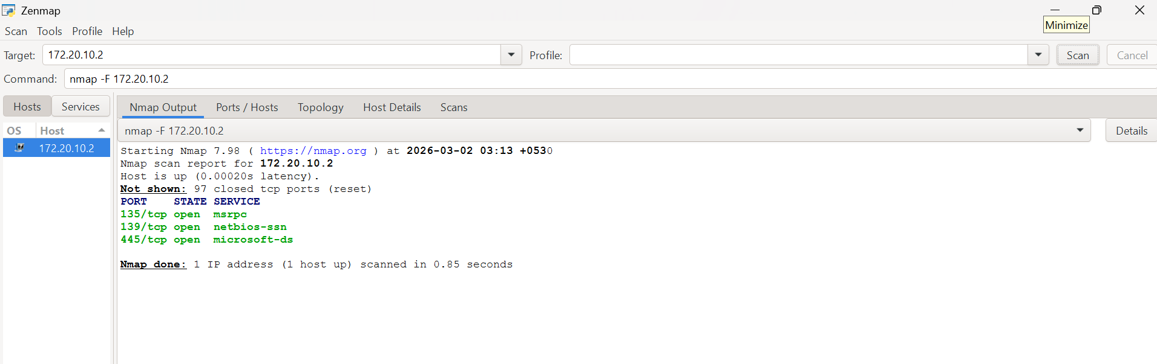
Its usage : This command gives info about top 100 open ports on target ip address. It specifies portnumber,state,service that can be run on that port number

8.Scanning a particular number of top ports:
nmap –top-ports {number of ports} target_ip : nmap –top-ports 50 172.20.10.2
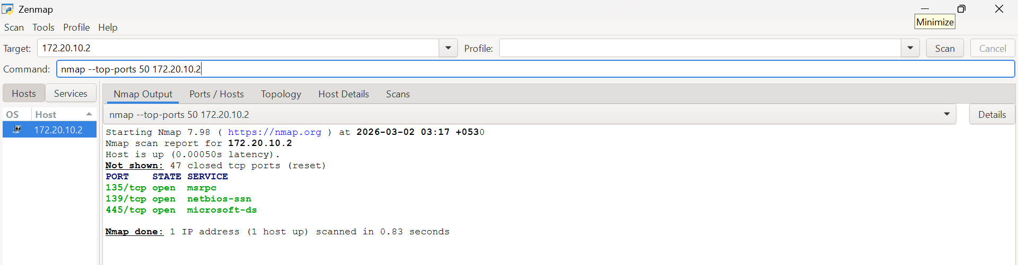
Its usage : This command gives info about specified number of top open ports on target ip address. It specifies portnumber,state,service that can be run on that port number

9.Stealth scan:
nmap -sS target_ip : nmap -sS 172.20.10.2
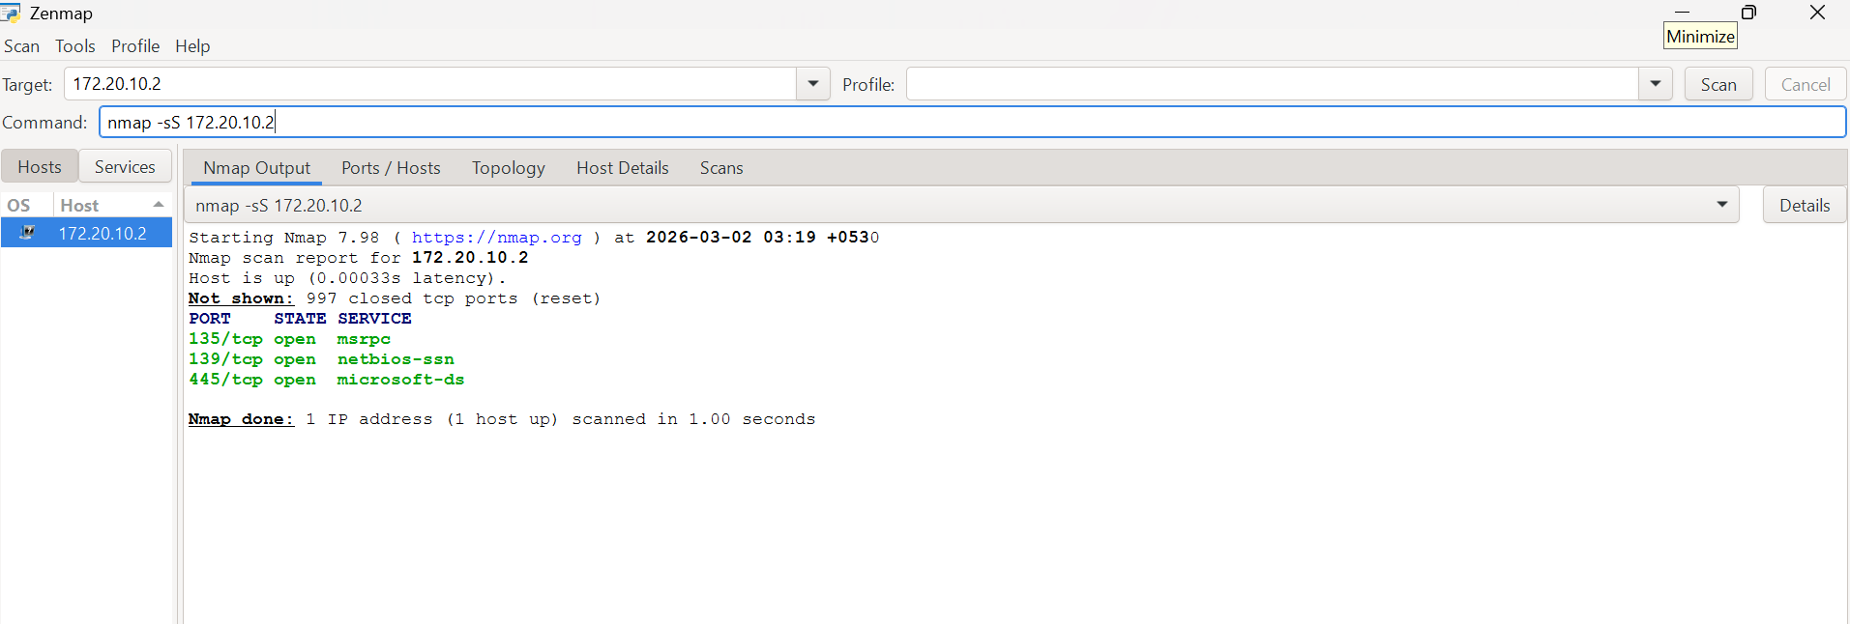
Its usage : Generally when not specified about which type of scan to perform nmap defaultly performs tcp scan but when specified it performs the particular type of scan, in that one type is Stealth scan. Although different scan types yield the same overall result regarding whether a port is open, closed, or filtered, the underlying techniques employed to determine that status vary. Also the time taken to scan also varies. Stealth scanning is also known as a half-open scan because it does not fully complete the three-way handshake with the target. Instead, it disconnects midway. This technique utilizes the three-way handshake process to determine the status of a port—specifically, whether it is open, closed, or filtered—and if a service is actively running on it.

10.TCP scan:
nmap -sT target_ip : nmap -sT 172.20.10.2
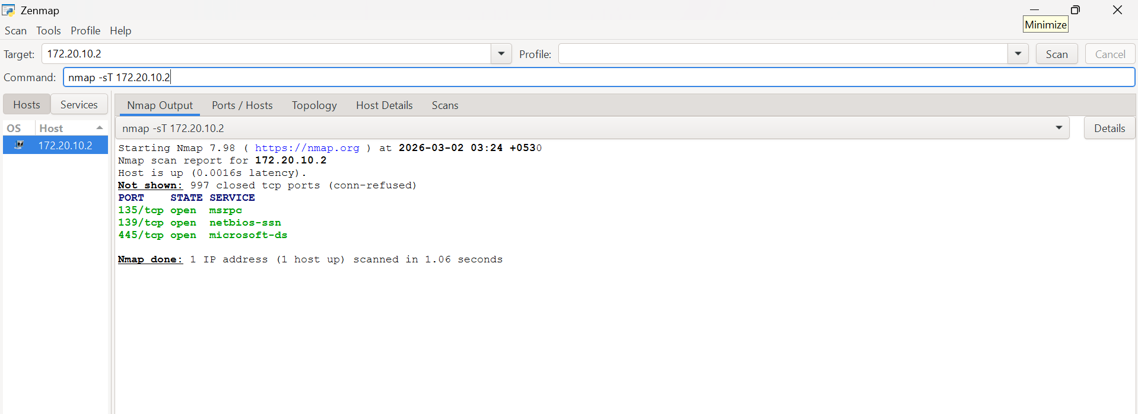

Its usage : In tcp scan the nmap completes 3-way handshake to detect if port is open or not. It takes more time than Stealth scan hence is slower.

11.UDP Scan:
nmap -sU target_ip : nmap -sU 172.20.10.2
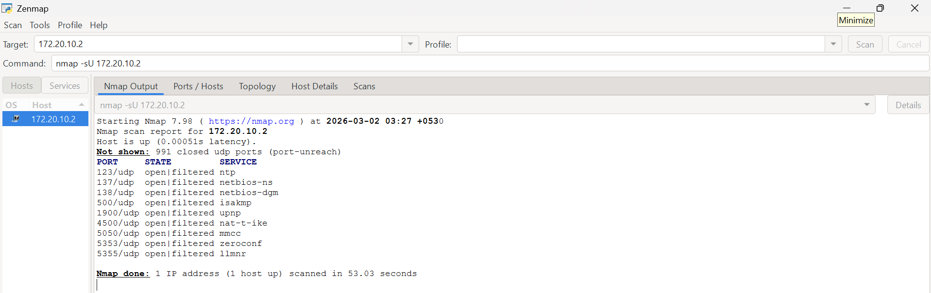

Its usage : TCP and SYN scans are limited to checking only TCP ports; they do not scan for UDP ports. These scans are capable of checking the top 1000 ports.

12.Service&Version detection:
nmap -sV target_ip : nmap -sV 172.20.10.2
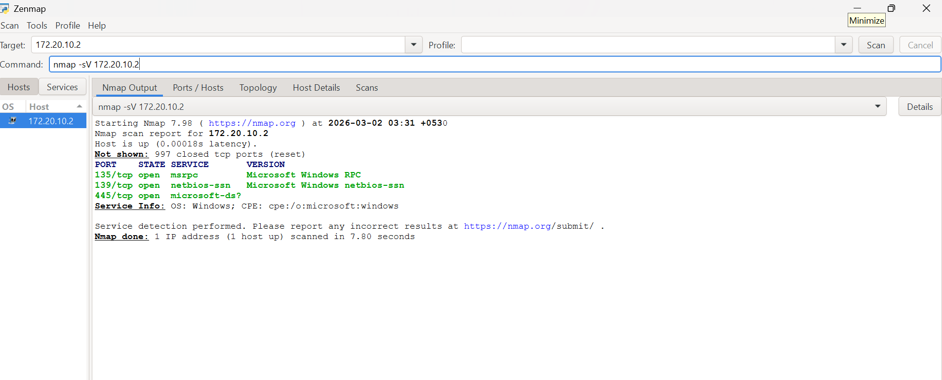
Its usage : This command specifies which services are running on top most open ports for a particular ip address and it also specifies versions of that services
How it detects : when nmap sends a request and get backs a request when it knows the port is open using 3-way handshake then it analyzes the response inorder to discover the version of service running

13.OS detection:
nmap -O target_ip : nmap -O 172.20.10.2
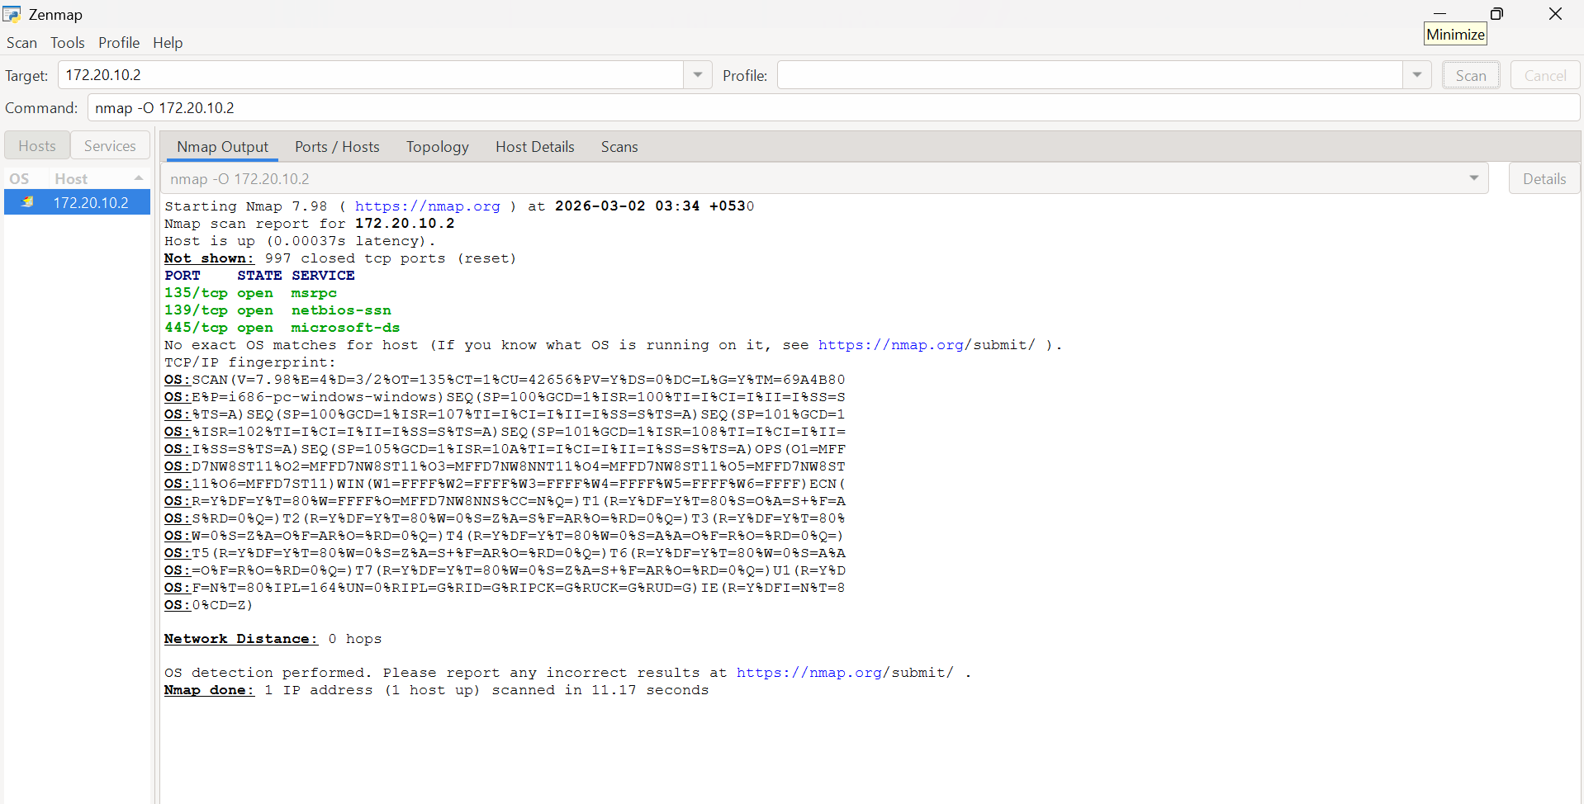
Its usage : This command specifies type of operating systems on a particular ip address it may not give exact os, but it gives accurate results that may vary in versions
How it detects : nmap sends a lot of requests to the target and when target responds based on all responses it analyses against a large database of nmap, this large database have various finger prints of os when nmap compares response with database whatever finger prints matches with that it, it detects that it can be that os

14.Aggressive Scan:
nmap -A target_ip : nmap -A 172.20.10.2
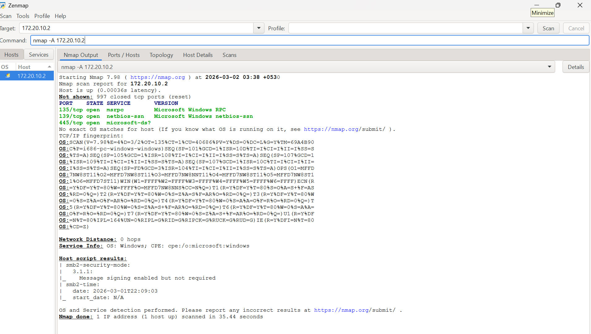
Its usage : It is an all in one scan. It can perform multiple tasks like detecting which ports are open, version detection, os detection, service detection, stealth scanning etc
Note : (not to use this because contains useless info, time waste, triggers the target,)

15.Timing Template:
nmap -T0/T1/T2/T3/T4/T5 target_ip : nmap -T5 172.20.10.2
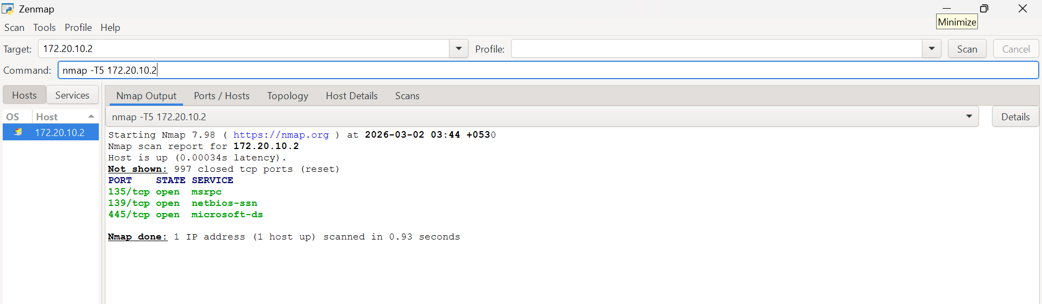
Its usage : consider it as a parameter which will decide how aggressive the scan will be: like scan can be fast or slow. It is represented as -T and has 5 states 0-5. T0 is very slow. T5 is for very fast response. By default nmap uses T3.

Part B: VirusTotal Intelligence Gathering
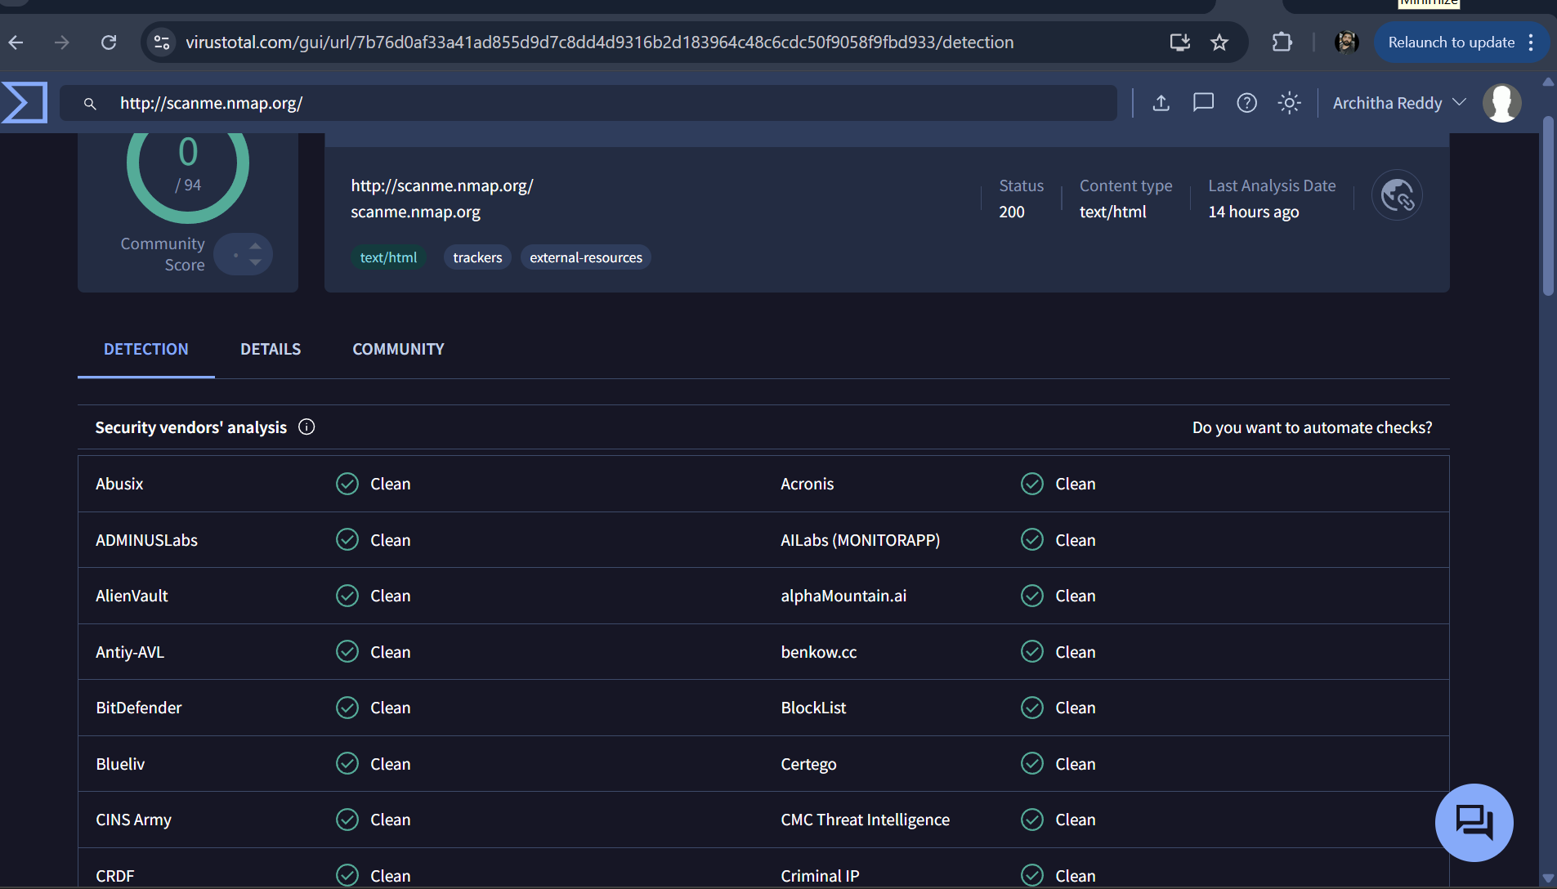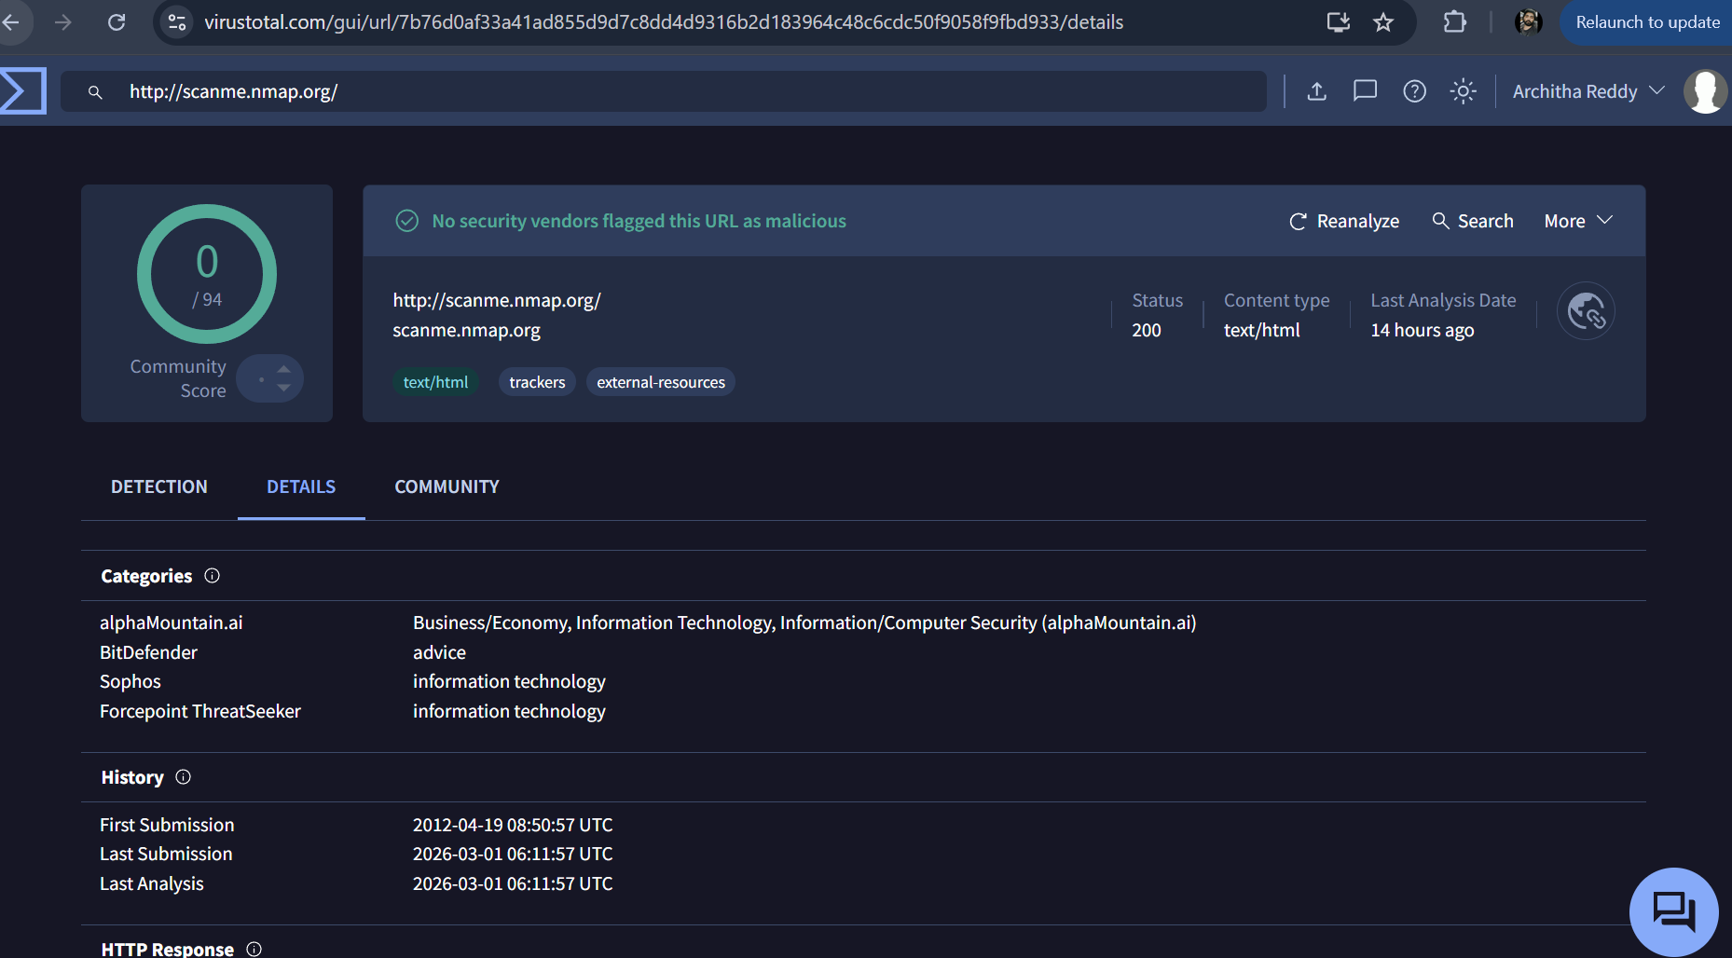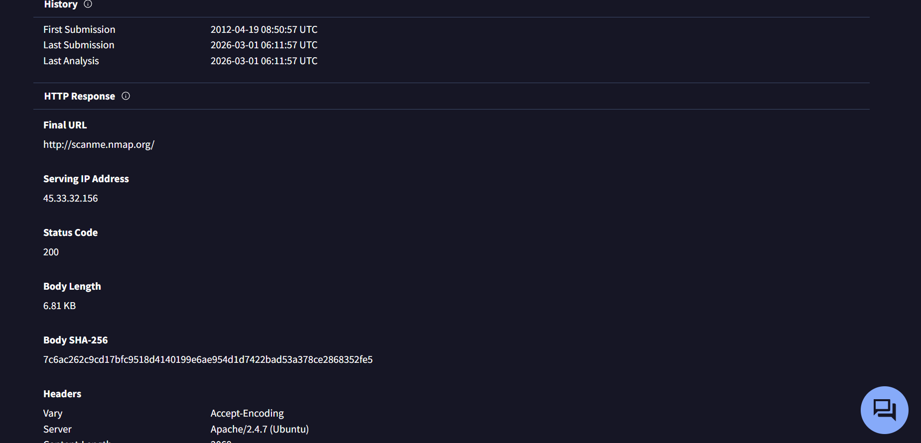
What VirusTotal is used for : VirusTotal is an online threat-intelligence platform used to:
- Check whether a domain, IP, URL, or file is known to be malicious or safe
- View existing security reports from many antivirus and cybersecurity companies
- Collect passive intelligence without directly interacting with the target
It doesn’t scan targets directly instead It combines the knowledge that is already collected by others and gives us info.
How passive intelligence differs from active scanning
Passive Intelligence (VirusTotal)
- We do not touch the target
- We only read existing data
- No packets are sent to scanme.nmap.org

Active Scanning (Nmap)
Nmap actively:
- Sends packets
- Probes ports
- Identifies services
Passive intelligence observes previously collected data, whereas active scanning directly interacts with the target to gather live information.
How VirusTotal findings support or complement your Nmap results

What Nmap tells us:
- Which ports are open
- Which services are running
- That the host is reachable
- And all the other advance info when different commands are used

What VirusTotal tells us
- Whether this exposure is normal or suspicious
- Whether the domain has a malicious reputation
- The context behind what we scanned
Port & Service Analysis :
1.Port number 21 : FTP (File Transfer Protocol)
Nmap service name: ftp
What Nmap detects:
- Port 21/tcp is open
- FTP service is listening
- May attempt to identify:
  - Anonymous login allowed?
  - FTP banner (server type)
Why security cares:
- FTP sends credentials in plain text
- Nmap flags this as a legacy/insecure service
2.Port 22 — SSH(Secure shell)
Nmap service name: ssh
What Nmap detects:
- SSH daemon is listening
- With -sV, Nmap may show:
  - OpenSSH version
  - OS hints
Why security cares:
- SSH = full remote control
- Attackers try brute-force attacks
3.Port 80 — HTTP(Hyper Text Transfer Protocol)
Nmap service name: http
What Nmap detects:
- Web server is running
- With scripts (-A), Nmap may detect:
  - Apache / Nginx
  - Website title
  - Server headers
Why security cares:
- Web apps often have vulnerabilities
- Port 80 is common and heavily tested
4.Port 443 — HTTPS(Hyper Text Transfer Protocol Secure)
Nmap service name: https
What Nmap detects:
- Secure web service
- Can detect:
  - TLS certificate info
  - Server software
  - SSL configuration issues
Why security cares:
- Misconfigured HTTPS = security risk
- Certificates reveal domain info
5.Port 3306 — MySQL
Nmap service name: mysql
What Nmap detects:
- Database service exposed
- With -sV, may reveal DB version
Why security cares:
- Databases should NOT be public
- Exposed DB = data leak risk
Vulnerability Reasoning:
Based on the service and version information, we can understand the possible risks involved. Services like SSH and web servers allow remote access and interaction with the system. If these services are not properly configured or are running outdated versions, they may become vulnerable to attacks. Although no exploitation was done, having these services open increases the attack surface of the system, which shows the importance of keeping services securely configured and regularly updated.

Conclusion :
Through this exercise I learned what is nmap, how nmap works, how each command works in nmap, what are ports, what are services, what exactly relation between port,service and ipaddress, states of ports like open,closed,filtered,open|filtered. I also learned about types of scans, timing template, how to use nmap. I also understood difference between virustotal and nmap, I have got clear info on how to use virustotal, which info is placed in virustotal, why we use virustotal. I got a clarity that virustotal is for observation and nmap is for practical use. I also learned how virustotal check whether a domain, IP, URL, or file is known to be malicious or safe.

